RFP ATTACHMENTS

FAIRFAX WATER
REQUEST FOR PROPOSALS NO. 18-18

ATTACHMENT A – PROPOSAL FORM

the undersigned understands and acknowledges the following:

The official, true, and complete copy of the solicitation documents, which shall include any ADDENDUMS thereto, is the electronic copy of the solicitation documents available from FW’s website at: http://www.fairfaxwater.org/procurement/current_bids.htm.

potential OFFEROrs are responsible for determining the accuracy and completeness of aLL solicitation documents they receive, including DOCUMENTS obtained from FW, AND DOCUMENTS obtained from aLL other sourceS.

l. ALL MATERIAL (PROPOSAL AND ATTACHMENTS) SUBMITTED SHALL BE IN TEN (10) COPIES, CONSISTING OF: ONE PROPOSAL, CLEARLY MARKED ON ITS COVER WITH THE WORD “ORIGINAL”, WHICH SHALL INCLUDE THIS PROPOSAL FORM CONTAINING AN ORIGINAL LONGHAND SIGNATURE; AND NINE (9) ADDITIONAL COPIES, WHICH SHALL INCLUDE A PHOTOCOPY OF THE ORIGINAL SIGNED PROPOSAL FORM AND A ELECTRONIC COPY OF THE PROPOSAL ON SHAREPOINT SITE ACCESSABLE BY FW. THE ORIGINAL, SIGNED PROPOSAL FORM SHALL BE THE FIRST PAGE OF THE ORIGINAL PROPOSAL.

2. INDICATE THE NAME AND CONTACT INFORMATION OF THE PERSON WHO CAN RESPOND AUTHORITATIVELY TO ANY QUESTIONS REGARDING THIS PROPOSAL (PROJECT MANAGER).

NAME (PRINTED): TITLE:

E-MAIL ADDRESS: ______TEL. NO.:

TRADE SECRETS OR PROPRIETARY INFORMATION:
Trade secrets or proprietary information submitted by an offeror in connection with a procurement transaction shall not be subject to public disclosure under the Virginia Freedom of Information Act. However, §2.2-4342. Public inspection of certain records, F., of the Virginia Public Procurement Act states that the offeror the bidder, offeror or contractor shall (i) invoke the protections of this section prior to or upon submission of the data or other materials, (ii) identify the data or other materials to be protected, and (iii) state the reasons why protection is necessary.

Please mark one:

( ) No, the proposal I have submitted does not contain any trade secrets and/or proprietary information.

( ) Yes, the proposal I have submitted does contain trade secrets and/or proprietary information.

PROPOSAL FORM, PAGE OF _______
If Yes, you must clearly identify below the exact data or other materials to be protected and list all applicable page numbers of the proposal containing such data or materials:

___________________________________________________________

___________________________________________________________

___________________________________________________________

___________________________________________________________

State the specific reason(s) why protection is necessary:

___________________________________________________________

___________________________________________________________

___________________________________________________________

___________________________________________________________

If you fail to identify the data or other materials to be protected and state the reasons why protection is necessary in the space provided above, you will not have invoked the protection of §2.2-4342. Public inspection of certain records, F., of the of the Code of Virginia. Accordingly, effective upon the award of contract, the proposal will be open for public inspection consistent with applicable law.

CERTIFICATION OF NON-COLLUSION: The undersigned certifies that this proposal is not the result of, or affected by, any act of collusion with another person (as defined in Code of Virginia Section 59.1-68.6 et seq.), engaged in the same line of business or commerce; or any act of fraud punishable under the Virginia Governmental Frauds Act (Code of Virginia §18.2-498.1 et seq.).

PROPOSAL FORM, PAGE OF

THE PROPER FULL LEGAL NAME OF THE FIRM OR ENTITY SUBMITTING THIS PROPOSAL MUST BE WRITTEN IN THE SPACE PROVIDED BELOW. THIS PROPOSAL FORM, AND ALL OTHER DOCUMENTS REQUIRED BY THE SOLICITATION TO BE SUBMITTED WITH THIS PROPOSAL FORM, INCLUDING, BUT NOT LIMITED TO ALL ISSUED ADDENDUMS, MUST BE FULLY AND ACCURATELY COMPLETED AND SIGNED BELOW BY A PERSON AUTHORIZED TO LEGALLY AND CONTRACTUALLY BIND THE OFFEROR, OR THE PROPOSAL MAY BE REJECTED:

AUTHORIZED SIGNATURE

PRINT NAME AND TITLE

SUBMITTED BY: (LEGAL NAME OF ENTITY)
ADDRESS:
CITY/STATE/ZIP:
TELEPHONE NO: |  |  |  | FACSIMILE NO.:
THIS FIRM IS A: • INSERT NAME OF STATE ____________________________
___ CORPORATION, ___ GENERAL PARTNERSHIP, ___ LIMITED PARTNERSHIP,
___ UNINCORPORATED ASSOCIATION, ___ LIMITED LIABILITY COMPANY,
___ SOLE PROPRIETORSHIP
IS FIRM AUTHORIZED TO TRANSACT BUSINESS IN THE COMMONWEALTH OF VA?
identification NO. issued to the firm by the SCC:
Any OFFEROr exempt from scc authorization requirement shall include a statement with its bid why they are not required to be so authorized
IS YOUR FIRM or any of its principals currently debarred from submitting bids to FAIRFAX WATER AURTHORITY, or any other state or political subdivision in the commonwealth of VIRGINIA?
OFFEROR STATUS: |  | MINORITY OWNED: |  | WOMAN OWNED: |  |  | NEITHER:

PROPOSAL FORM, PAGE OF

Insurance Checklist
Certificate of Insurance must show all coverage and endorsements indicated by "X"
COVERAGES REQUIRED |  |  |  | LIMITS (FIGURES DENOTE MINIMUMS)
X | 1 | Workers' Compensation |  | Statutory limits of Virginia
X | 2 | Employer's Liability |  | $100,000 accident, $100,000 disease, $500,000 disease policy limit
X | 3 | Commercial General Liability(CGL) |  | $1,000,000 CSL BI/PD each occurrence, $2 Million annual aggregate
X | 4 | Premises/Operations |  | $500,000 CSL BI/PD each occurrence Million annual aggregate
X | 5 | Automobile Liability |  | $1 Million BI/PD each accident, Uninsured Motorist
X | 6 | Owned/Hired/Non-Owned Vehicles |  | $1 Million BI/PD each accident, Uninsured Motorist
X | 7 | Independent Contractors |  | $500,000 CSL BI/PD each occurrence, $1 Million annual aggregate
 | 8 | Products Liability |  | $500,000 CSL BI/PD each occurrence, $1 Million annual aggregate
X | 9 | Completed Operations |  | $500,000 CSL BI/PD each occurrence, $1 Million annual aggregate
X | 10 | Contractual Liability (Must be shown on Certificate) |  | $500,000 CSL BI/PD each occurrence
 | 11 | Personal and Advertising Injury Liability |  | $1 Million ea. offense, $1 Million annual aggregate
 | 12 | Umbrella Liability |  | $1 Million Bodily Injury, Property Damage and Personal Injury
 | 13 | Per Project Aggregate |  | $1 Million per occurrence/claim
 | 14 | Professional Liability
 | 14 | a | Architects and Engineers | $1 Million per occurrence/claim
 | 14 | b | Asbestos Removal Liability | $2 Million per occurrence/claim
 | 14 | c | Medical Malpractice | $1 Million per occurrence/claim
 | 14 | d | Medical Professional Liability | $1 Million per occurrence/claim
 | 15 | Miscellaneous E&O |  | $1 Million per occurrence/claim
 | 16 | Motor Carrier Act End. (MCS-90) |  | $1 Million BI/PD each accident, Uninsured Motorist
 | 17 | Motor Cargo Insurance
 | 18 | Garage Liability |  | $1 Million Bodily Injury, Property Damage per occurrence
 | 19 | Garage keepers Liability |  | $500,000 Comprehensive, $500,000 Collision
 | 20 | Inland Marine-Baillie’s Insurance |  | $
 | 21 | Moving and Rigging Floater |  | Endorsement to CGL
 | 22 | Dishonesty Bond |  | $
 | 23 | Builder's Risk |  | Provide Coverage in the full amount of Contract
X | 24 | XCU Coverage |  | Endorsement to CGL
 | 25 | USL&H |  | Federal Statutory Limits
X | 26 | Carrier Rating shall be Best's Rating of A-VII or better or its equivalent
X | 27 | Notice of Cancellation, nonrenewal or material change in coverage shall be provided to FAIRFAX WATER at least 30 days prior to action
X | 28 | The FAIRFAX WATER shall be an Additional Insured on all policies except Workers Compensation, Professional Liability, and Automobile Liability
X | 29 | Certificate of Insurance shall show Solicitation Number and Title

INSURANCE AGENT'S STATEMENT:
I have reviewed the above requirements with the offeror named below and have advised the offeror of required coverages not provided through this agency.

AGENCY NAME: AUTH. SIGNATURE:

OFFEROR'S STATEMENT:
If awarded the Contract, I will comply with contract insurance requirements.

OFFEROR NAME: AUTH. SIGNATURE: __________________________

Attachment B – Experience and Competency
Complete as appropriate to Offeror’s experience and current state the fields in white.

Experience and Competency
Years Supporting Similar or Larger Solution
List client and project name of similar or larger recently completed projects executed (minimum of 10) | # | Client Name | Project Name
 | 1
 | 2
 | 3
 | 4
 | 5
 | 6
 | 7
 | 8
 | 9
 | 10
SAP Partner Standing
SAP Partner Level
SAP Partner Recognitions/Awards

Attachment C – Third Party Software or Services
Complete as appropriate the following form for each 3rd party software or service proposed by the Offeror to complete the Solution.

3rd Party Software or Services
Company Name
Software or Service
Description of Purpose in Solution
Company’s prior hosting experience

Attachment D – Detailed Solution Experience
Complete the following form for 4 of the 10 clients listed in Attachment B that had a recent similar or larger Solution experiences.
Detailed Solution Experience
Client Name
Project Name
Point-of-Contact (POC) Name
POC Role (preferably the Contract Project Manager)
POC Email Address
POC Phone Number
Stakeholder Size & Diversity
Estimated Duration of SAP Hosting, Basis and Application Management contract
Actual Duration of SAP Hosting, Basis and Application Management contract
Original Contract Amount | $
Final Actual Contract Amount | $
Estimated Duration of Migration
Actual Duration of Migration
Summary of Solution, including complexity of landscape
Describe any challenges and how you resolved the | - <Challenge>  - <Resolution>
Names of the key personnel and roles supporting the implementation, specifically proposed staff for RFP Solution.  (Add additional roles as appropriate) | Key Personnel | Role | Proposed Staff Member for this RFP Solution  (Yes / No)
Rate your performance on the project using a scale from 1 - 10 with 1 being poor performance and 10 being superb performance. Provide an explanation for each rating

Attachment E – Project Team Staff
Provide a list of project team staff proposed to implement the Solution

Project Team Staff
Role
Years of experience in Role
Description of Role
Percentage of Time Allocated and Dedicated to Project

Attachment F – Hosting Personnel
Complete the following form for all key personnel proposed to implement the Solution. And complete the form for backup personnel if the key personnel is unavailable to implement the Solution
Hosting Personnel
Key Personnel or Backup | <Enter either: Key Personnel OR Backup>
Personnel Name
Years of Experience in Proposed Role
Years of experience with offeror
Competency (Certified SAP infrastructure personnel preferred)
Identify which project deliverables and/or tasks the person will complete
List of projects and role and capacity for which the person has acted.  Note: Highlighting the projects included in the 10 clients list using or implementing the proposed Solution. | Project Name | Role | Duration on Project | % Capacity / Dedicated to Projected to Project

Attachment G – Pricing Workbook
The pricing workbook is made up of six worksheets as shown below: Instructions; 1 – Pricing – Existing Landscape, 2 – Pricing – SAP Business Suite on HANA; 3 – Managed Services Rate Card; 4 – Resources rate Card and 5 – Pricing Assumptions. Use the FW provided Microsoft Excel Pricing Workbook to complete this proposal submittal element.

Instructions
RFP No. 18-18 - Enterprise Application Managed Hosting Services
Pricing Response Workbook | Instructions
INSTRUCTIONS: Provide pricing to include any and all related costs, fees and/or expenses.
GREEN SHADED FIELDS SHOULD BE FILLED OUT BY THE OFFEROR.
Tab Name | Tab Description
1 - Pricing - Existing Landscape | Provide RFP Solution's Total Costs, including reoccurring and non-reoccurring costs:  - All non-reoccurring costs for the Solution should be listed.  - Reoccurring costs should include duration and escalation assumptions given in 4 - Pricing Assumptions worksheet.  - Make sure to include any one-time expenses, any hardware, software licenses, subscription fees, implementation fees, travel and expenses.  - Add additional rows as necessary for reoccurring or non-reoccurring costs.
2 - Pricing - SAP Business Suite on HANA | Provide RFP Solution's Total Costs, including reoccurring and non-reoccurring costs:  - All non-reoccurring costs for the Solution should be listed.  - Reoccurring costs should include duration and escalation assumptions given in 4 - Pricing Assumptions worksheet.  - Make sure to include any one-time expenses, any hardware, software licenses, subscription fees, implementation fees, travel and expenses.  - Add additional rows as necessary for reoccurring or non-reoccurring costs.
3 - Managed Services Rate Card | Input all rate card information for managed services/offerings that are in addition to services covered by the recurring Monthly Hosting, DR & Support costs. For example: Additional Client Copies, System Refreshes, Bandwidth increases, additional storage, backups, systems and any other offerings
4 - Resource Rate Card | Input all rate card information for resource personnel:  - Include both Offeror staff and 3rd party contractors  - Include personnel for the Hosting Migration and any future Maintenance and Support functions. Indicate in the columns provided whether resource is planned for Migration and/or Support/Maintenance.  - Make sure to cover consulting and development services in support of the Solution.  - Add/modify the rows as appropriate to include all Offeror Team members.
5 - Pricing Assumptions | Identify any Pricing Assumptions in this worksheet. Please also include any assumptions about price escalation in this section.
Note: Within each worksheet, please ensure that you scroll down to pick up all response information required.
PLEASE DO NOT INSERT OR DELETE ANY ROWS OR COLUMNS IN THIS WORKBOOK UNLESS ADDITIONAL INSTRUCTIONS WITHIN THE SPECIFIC WORKSHEET ALLOW YOU TO DO SO.

- Pricing – Existing
RFP No. 18-18 - Enterprise Application Managed Hosting Services
Pricing Response Workbook | Pricing - Existing Landscape
INSTRUCTIONS: Please provide the pricing for each scoped area of the Solution, including all resources (e.g., infrastructure, services, and Offeror and 3rd party personnel). Line items may be added as needed. The objective is to ascertain a comprehensive picture of pricing for the proposed Solution at a componentized level to understand the cost factors for what is proposed, and to clearly understand which pricing components might be fixed versus those that might vary to eliminate and avoid "hidden" costs or unplanned cost variances for the Solution throughout its life.
TOTAL (Non-Reoccurring and Reoccurring Costs) |  | $ -
Task/Item |  | Total
Non-Reoccurring Costs (including One-Time Expenses)
Scoped Solution Costs:
One-time Set Up and Migration
Other Non-Reoccurring Costs:
<Add rows for each other itemized costs as needed (e.g. one-time expenses, hardware, software license, subscription fees, implementation fees, travel and expenses, etc.)>
Total |  | $ -
Reoccurring Costs (If Applicable)
<Add any reoccurring costs (e.g. Other 3rd party software subscriptions, on-going maintentance and support packages).
Include any duration and escalation assumptions on the "3- Pricing Assumptions" worksheet.>
Monthly Hosting & Support |  | $ -
Hardware Costs
Storage Costs
Network Costs
Application and Database Licenses
Support Services
Monthly DR & Support |  | $ -
Hardware Costs
Storage Costs
Network Costs
Application and Database Licenses
Support Services
Total |  | $ -

- Pricing – HANA
RFP No. 18-18 - Enterprise Application Managed Hosting Services
Pricing Response Workbook | Pricing - SAP Business Suite on HANA
INSTRUCTIONS: Please provide the pricing for each scoped area of the Solution, including all resources (e.g., infrastructure, services, Offeror and 3rd party personnel). Line items may be added as needed. The objective is to ascertain a comprehensive picture of pricing for the proposed Solution at a componentized level to understand the cost factors for what is proposed, and to clearly understand which pricing components might be fixed versus those that might vary to eliminate and avoid "hidden" costs or unplanned cost variances for the Solution throughout its life.
TOTAL (Non-Reoccurring and Reoccurring Costs) |  | $ -
Task/Item |  | Total
Non-Reoccurring Costs (including One-Time Expenses)
Scoped Solution Costs:
One-time Set Up and Migration
Other Non-Reoccurring Costs:
<Add rows for each other itemized costs as needed (e.g. one-time expenses, hardware, software license, subscription fees, implementation fees, travel and expenses, etc.)>
Total |  | $ -
Reoccurring Costs (If Applicable)
<Add any reoccurring costs (e.g. Other 3rd party software subscriptions, on-going maintenance and support packages).
Include any duration and escalation assumptions on the "3- Pricing Assumptions" worksheet.>
Monthly Hosting & Support |  | $ -
Hardware Costs
Storage Costs
Network Costs
Application and Database Licenses
Support Services
Monthly DR & Support |  | $ -
Hardware Costs
Storage Costs
Network Costs
Application and Database Licenses
Support Services
Total |  | $ -

- Managed Services Rate Card
RFP No. 18-18 - Enterprise Application Managed Hosting Services
Pricing Response Workbook | Managed Services Rate Card
INSTRUCTIONS: Please provide your rate card details.
# | Service |  | Costs
1
2
3
4
5
6
7
8
9
10
11
12
 | Example: Additonal Client Copies, System Refreshes, Bandwidth increases, additional storage, backups, systems and any other offerings.

- Resource Rate Card
RFP No. 18-18 - Enterprise Application Managed Hosting Services
Pricing Response Workbook | Resource Rate Card
INSTRUCTIONS: Please provide your rate card details. Do not provide a blended rate. Please identify each resource and their corresponding rate.
# | Role |  | Total Hourly Rate (Fully Burdened) |  | Overhead % |  | Profit % |  | Hours |  | Costs |  | Personnel for Migration |  | Personnel for Maintenance and Support |  | Location
1 |  |  |  |  |  |  |  |  |  |  | $ -
2 |  |  |  |  |  |  |  |  |  |  | $ -
3 |  |  |  |  |  |  |  |  |  |  | $ -
4 |  |  |  |  |  |  |  |  |  |  | $ -
5 |  |  |  |  |  |  |  |  |  |  | $ -
6 |  |  |  |  |  |  |  |  |  |  | $ -
7 |  |  |  |  |  |  |  |  |  |  | $ -
8 |  |  |  |  |  |  |  |  |  |  | $ -
9 |  |  |  |  |  |  |  |  |  |  | $ -
10 |  |  |  |  |  |  |  |  |  |  | $ -
11 |  |  |  |  |  |  |  |  |  |  | $ -
12 |  |  |  |  |  |  |  |  |  |  | $ -

- Pricing Assumptions

RFP No. 18-18 - Enterprise Application Managed Hosting Services
Pricing Response Workbook | Pricing Assumptions
INSTRUCTIONS: Please provide the Offeror's assumptions used in the development of the cost estimates.
The following assumptions should be used in the development of the cost estimates: Please reference contents of the RFP to understand requirements, user base/geographies, and modules needed.
Offeror MUST clearly list and describe here all assumptions related to its proposal and MUST describe the anticipated impact in terms (e.g., effort, etc.).
Any assumption that is not listed and agreed upon below will NOT be considered to have an impact on pricing.
Pricing Assumptions / Rationale | RFP or Proposal Section Reference  (if applicable) | Description of Anticipated Impact

Attachment H - Hosted SAP Landscape
FW SAP reference information on the platform and modules.

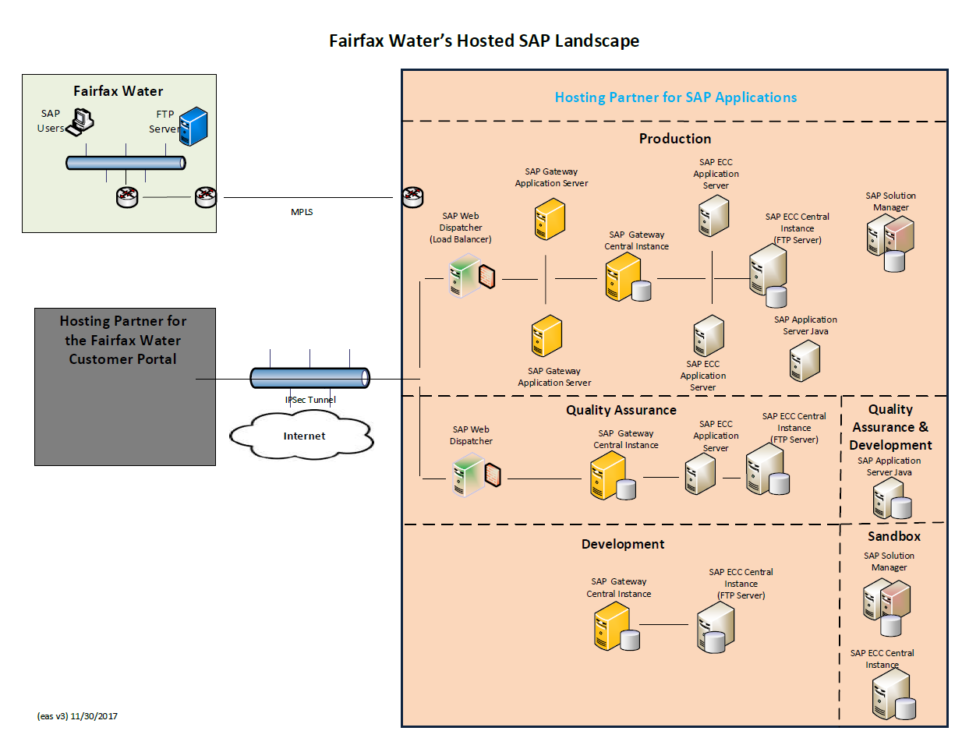

Attachment I - SAP Systems

FW has eighteen active SAP systems in service with its hosting partner. They are distributed across the following landscapes: Break/fix and Sandbox. SAP systems provided solely for disaster recovery are not listed.

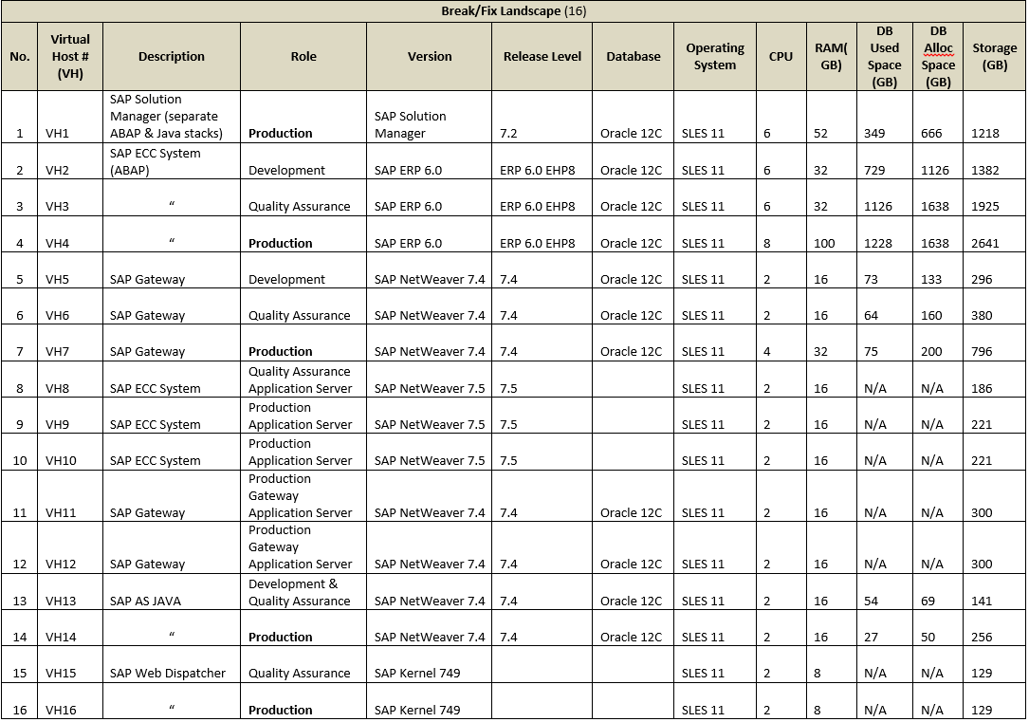
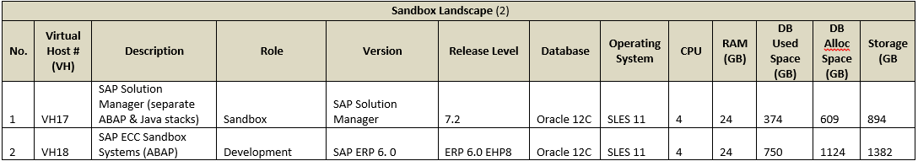

FW also has one production system in-house.

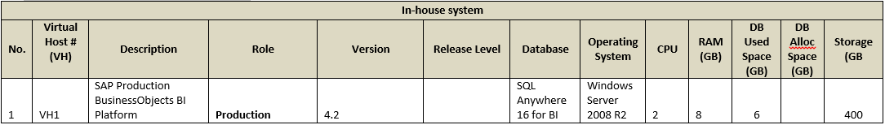

Attachment J - Network Access for SAP Operations
