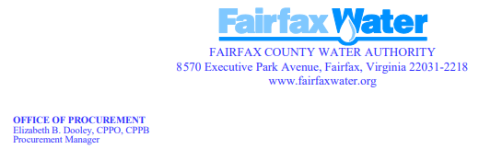

NOTICE OF INTENT TO AWARD
Intent to award has been made to the Proposers listed below:

Date Posted: 12/9/2024
Anticipated Award Date: 01/02/2025
Project Name: Ozone Instrumentation, Maintenance & related Services
Contract Number: 2024-127
Contractor: ChemTrac Inc.
Contract Amount: Not to exceed Two Hundred Thousand Dollars. - $200,000.00
Procurement Contact: Paula Martinez MBA, CPPB. pmartinez@fairfaxwater.org

