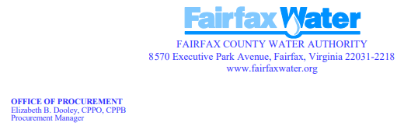

NOTICE OF INTENT TO AWARD
Intent to award has been made to the Proposers listed below:

Date Posted: 5/12/2025
Anticipated Award Date: 5/16/2025
Project Name: Classification and Compensation Study
RFP Number: 2025-018
Contractor: Mercer LLC
Contract Amount: Not to exceed Four Hundred Thousand Dollars. - $400,000.00
Procurement Contact: Paula Martinez MBA, CPPB. pmartinez@fairfaxwater.org

