FAIRFAX WATER

WATER SUPPLY STAKEHOLDER OUTREACH PROGRAM

GRANT APPLICATION GUIDELINES AND FORMS

FISCAL YEAR 2018

- ELIGIBILITY

  - Eligible Projects

The project or activity for which the funding is to be used shall address water supply and/or watershed issues within areas served by Fairfax Water, including wholesale customers, or within the portions of the watershed providing source water to Fairfax Water’s customers lying in Fairfax, Loudoun, Prince William, or Fauquier Counties, or the Cities of Manassas and Manassas Park. The specific types of projects that are eligible for funding include:

    - Education. Eligible education projects may include seminars, programs, or tours aimed at educating the public on water supply. Topics may include, but are not limited to, hydrology, water treatment processes, water distribution, watersheds, non-point source pollution, erosion and sediment control, or any related topic. Examples include weekend seminars for homeowners on watershed friendly lawn-care practices, or school programs on water supply issues. Education projects must be targeted towards either areas served by Fairfax Water, including wholesale customers (See Map 2), or portions of the watershed outlined in Map 1 lying in Fairfax, Loudoun, Prince William, or Fauquier Counties, or the Cities of Manassas and Manassas Park.

    - Source Water Protection. Source water protection projects may include stream restoration projects, non-point source pollution management projects, or other activities aimed at improving the quality of source waters that provide water for Fairfax Water’s customers. Example projects include stream bank stabilization, implementation of Best Management Practices (BMPs), or other projects aimed at improving water quality. Source water protection projects must be coordinated through the appropriate local or state agency, where applicable. Source water protection projects must be located within the watershed outlined in Map 1 and within Fairfax, Loudoun, Prince William, or Fauquier Counties, or the Cities of Manassas and Manassas Park.

    - Water Quality Monitoring. Water quality monitoring projects are eligible for Fairfax Water grant funds. Monitoring projects may include, but are not limited to, stream flow measurement, water quality constituent concentration, biological health, or erosion. Monitoring projects must be targeted towards either areas served by Fairfax Water, including wholesale customers (see Map 2), or the portions of the watershed, as outlined in Map 1, lying in Fairfax, Loudoun, Prince William, or Fauquier Counties, or the Cities of Manassas and Manassas Park

    - Occoquan Reservoir Shoreline Stabilization. Property owners may apply for a grant to support stabilization projects aimed at restoring the shoreline along the Occoquan Reservoir. The property must be located immediately adjacent to the Occoquan Reservoir, between the Occoquan High Dam and Hemlock Overlook Regional Park or between the Occoquan High Dam and the Lake Jackson Dam (see Map 3). Projects may include replanting of previously cleared areas that are exempted from restoration requirements established by all other federal, state, and local regulations; stabilization of eroded reservoir shoreline areas; or enhancement of the vegetated stream buffer adjacent to the reservoir. Only native, non-invasive, species may be used for buffer restoration. Information on native and invasive species may be obtained from the Virginia Department of Environmental Quality’s Riparian Buffer Modification & Mitigation Guidance Manual (search “riparian buffer” at http://www.deq.virginia.gov). Vegetative stabilization practices are required unless severe erosion of the shoreline or other technical considerations justify the installation of a hardened or structural stabilization practice. Applicants for shoreline stabilization projects are required to receive pending approval from Fairfax Water as identified in the procedures section of the Occoquan Reservoir Shoreline Easement Policy prior to submitting a grant application. These projects must receive final approval from Fairfax Water and the appropriate local, state, and/or federal agencies prior to their construction.
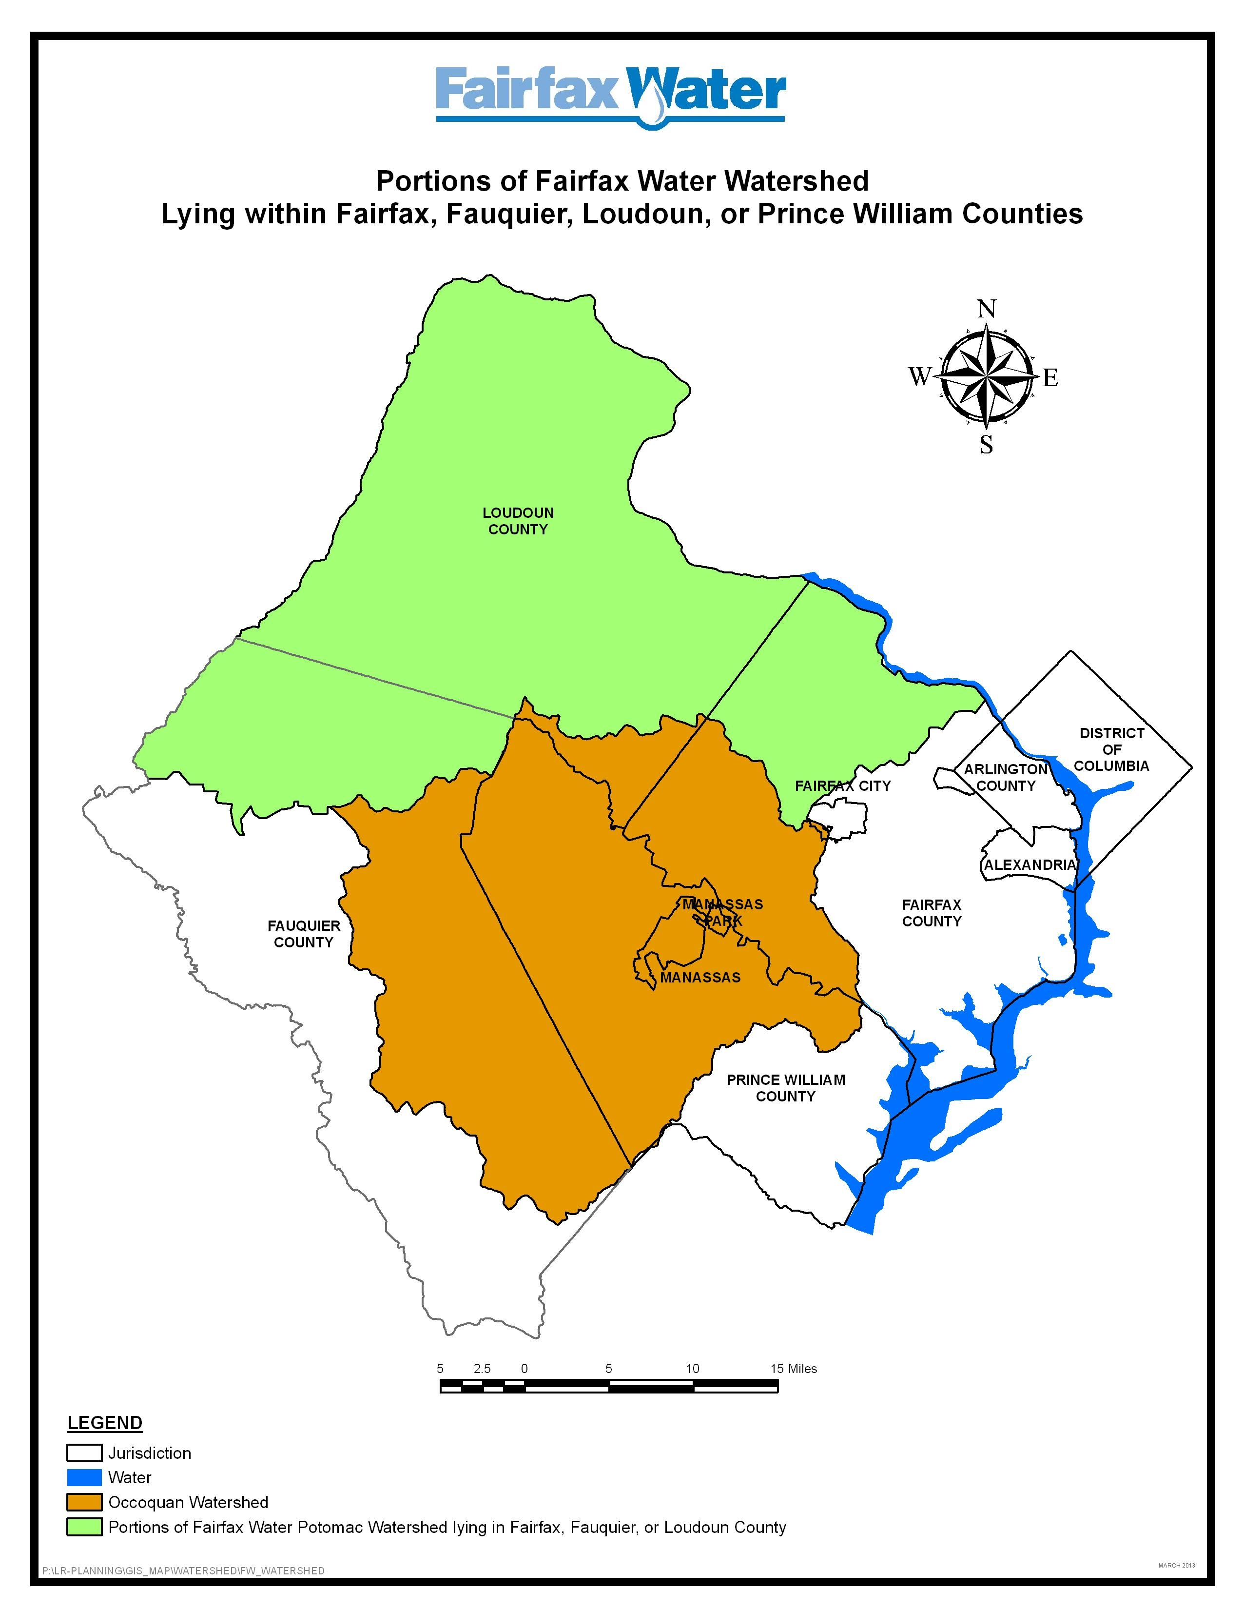
Map 1: Watershed Areas Eligible for Source Water Protection, Education, or Monitoring Projects.
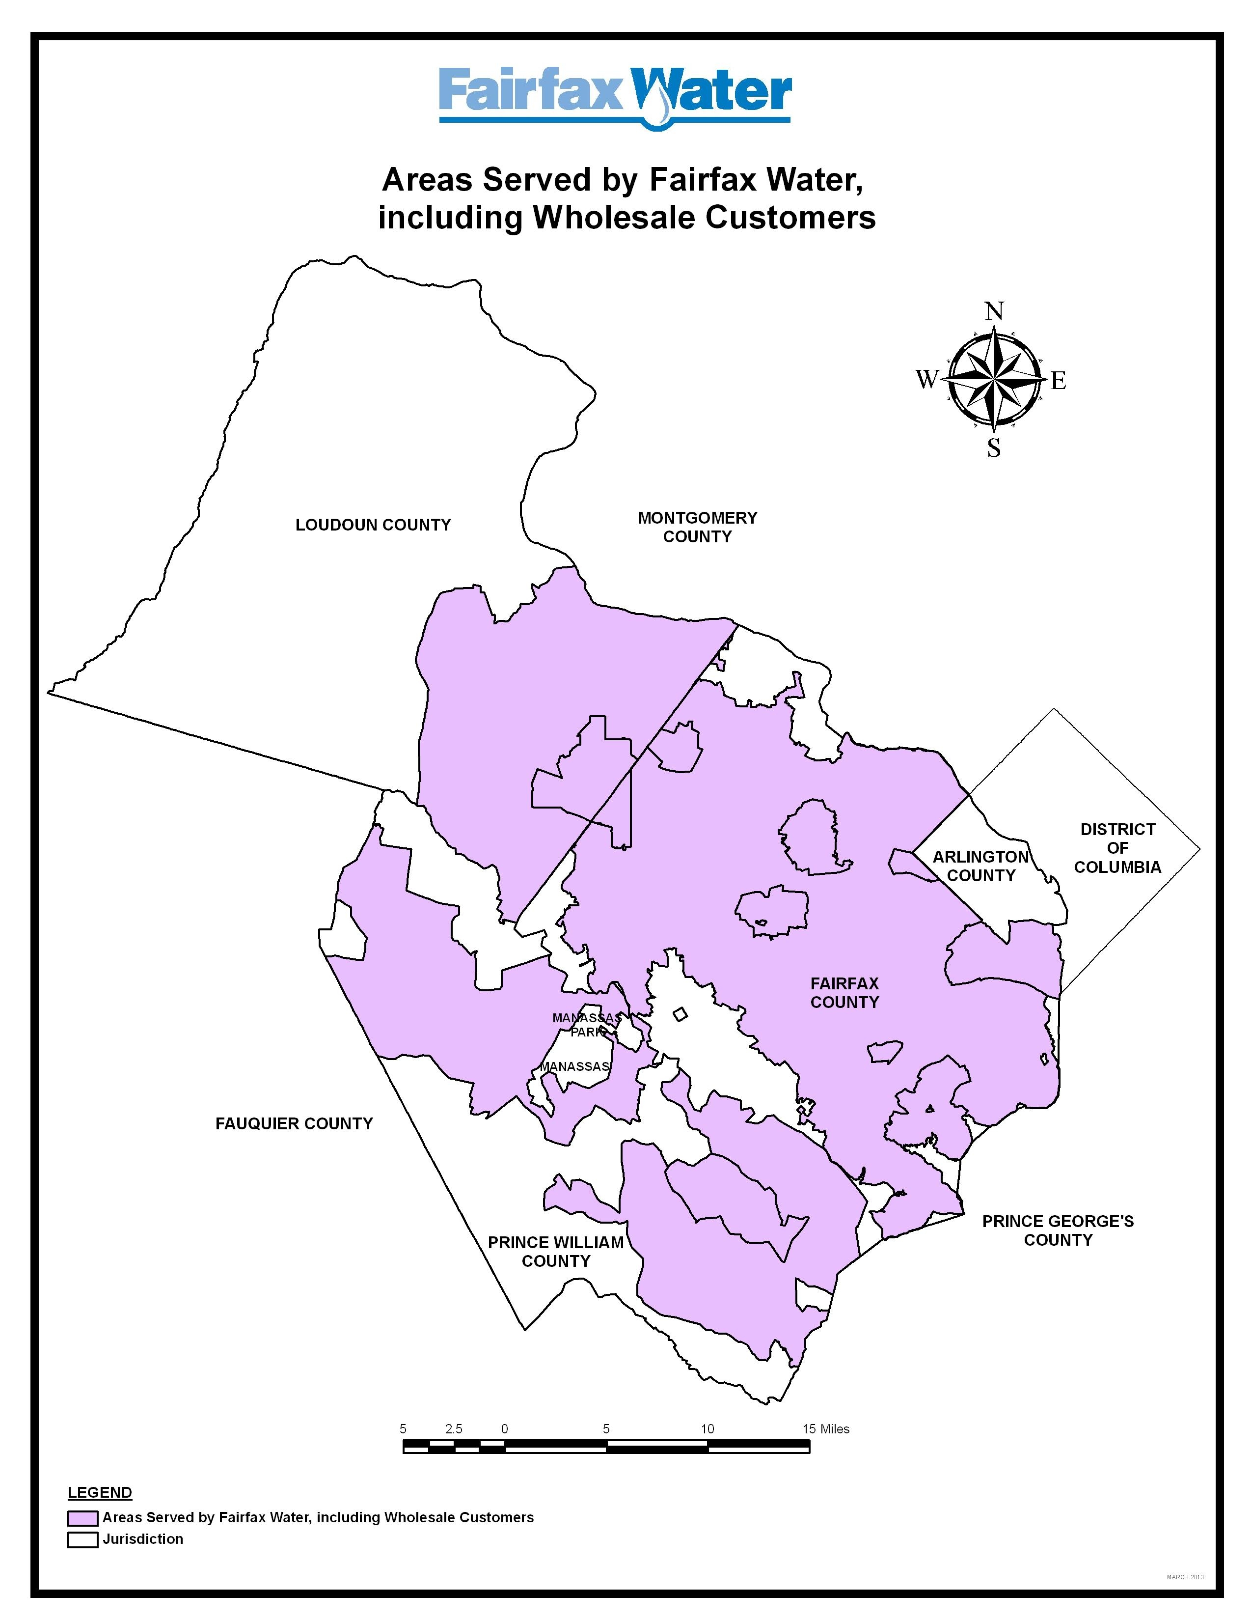
Map 2: Areas Eligible for Education or Monitoring Projects.
Occoquan Reservoir Shoreline Area Eligible for Fairfax Water Grants

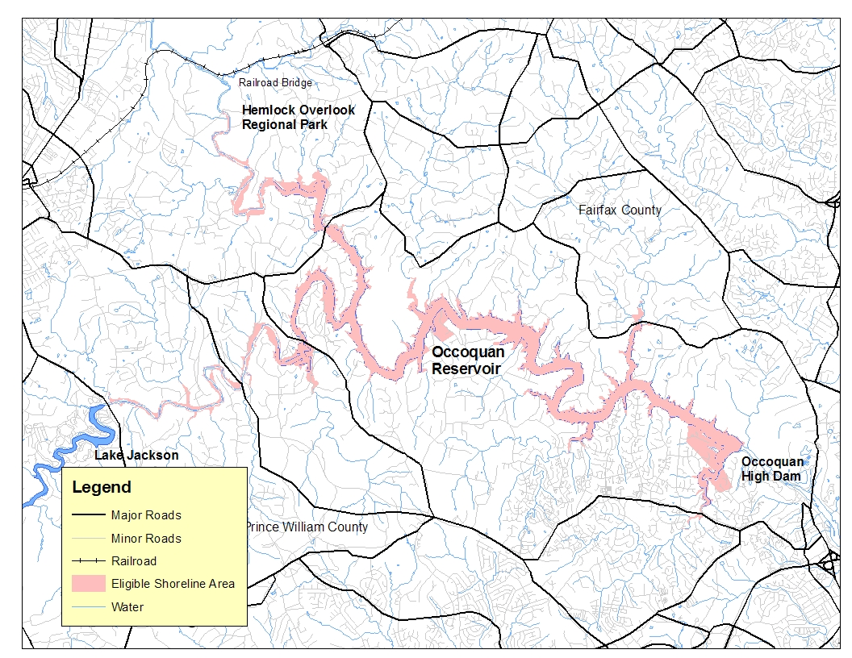

Map 3. Areas Eligible for Occoquan Reservoir Shoreline
Stabilization Grants.

  - Eligible Fund Uses

Funding shall be used to cover only costs associated with the proposed project. This includes purchase of equipment or materials to support the project, labor costs, or fees associated with conducting an educational program, such as room rental or group transportation. Although the grant must be used to support only the project detailed in the application, use of funds to purchase items that can be reused for additional projects, such as lab equipment, boats, or safety vests, for example, is encouraged.

  - Eligible Applicants

Any local government education agency, state government education environmental agency, homeowners association, civic group, or not-for-profit organization may apply for a grant. For education, source water protection, or water quality monitoring projects, the application must be submitted and sponsored by an organization, not an individual. All applicants must submit an IRS Form W-9 with the application. Organizations must submit proof of their tax-exempt status (such as a copy of their tax-exempt certificate). Grant funds distributed to individuals for shoreline stabilization projects will be reported to the IRS and may be considered taxable income*. Individuals must provide a taxpayer identification number or social security number.

The applicant must use the funds and may not redistribute any of the funds to another organization. Any organization already financed by Fairfax Water through an established program may not apply for this grant.

  - Multiple or Repeat Requests

Although an organization may submit more than one application at a time, no more than one grant shall be awarded to the same organization or property owner during the same grant cycle. The applicant is responsible for coordinating other applications by the same organization. Applicants who were awarded funds in a previous year may apply for an additional grant during subsequent years. Having received funds in previous years provides neither an advantage nor a disadvantage during the current year. Each request for funds shall be evaluated against the other requests received that year.

Individual owners of contiguous property along the Occoquan Reservoir may join together to apply for a common project. Each property owner shall complete the grant application certification form and indicate the names of all common property owners on the application.
* For tax advice or more technical questions about how tax laws apply, please consult your tax adviser.

  - Activities/Items Not Eligible for Funding

Activities that are not eligible for funding include mementos (such as t-shirts, pins, hats, etc.) and general administrative costs incurred by the organization such as telephone, printing, or postage not specifically associated with the proposed project. Funding may not be used to support lobbying efforts at any local, state, or federal level, even if the subject lobbying supports and is consistent with Fairfax Water goals. Funding may not be used to cover existing routine maintenance responsibilities.

- PROGRAM ELEMENTS

Major elements of the Grant Program are described below. For organizations applying for source water protection or education projects, grants may be in the form of funding, technical services or a combination thereof, in an amount not to exceed a total of $10,000. Grants for erosion control projects on private property along the Occoquan Reservoir may not exceed a total of $5,000 per property.

  - Funds

The applicant may apply for funding to cover the project either in whole or in part. Matching funds from the applicant are preferred but not required for projects up to $5,000. Matching funds of at least a dollar for dollar match are required for any grant portion greater than $5,000. For example, a grant request of $7,500 requires the applicant to provide a match of at least $2,500.

  - Technical Services

Fairfax Water technical support staff may provide technical services directly as part of the grant program. Applicants may be granted a fixed number of defined staff hours from Fairfax Water for support such as mapping, laboratory testing, or surveying to support their project.

- SELECTION CRITERIA

An objective approach based on predefined criteria is used to select organizations to receive grants. Selection criteria include:

  - Project Purpose

The project purpose must be clearly identified and defined. For source water protection projects, the water quality problem being addressed should be identified. For educational programs, the target audience and purpose of the program should be defined. For volunteer monitoring projects, the stream or water body to be sampled should be identified and how the monitoring data is expected to be used should be described.

  - Justification

The project must directly support and relate to Fairfax Water purposes. This includes educational programs on any aspect of water supply, treatment, or distribution; watershed management; and watershed protection. This also includes source water protection projects with well-defined water quality goals.

  - Sustainability

Fairfax Water encourages sustainable or continuing projects. For educational programs, follow-up programs should be conducted. For source water protection projects, an effort should be made to maintain and monitor the project to determine its success over time. For example, if a stream bank is stabilized, the project should be assessed periodically to ensure that stability has been maintained in the stream. Although not required, a sustainable or continuing project is more likely to receive support.

  - Quantifiable Results

The project should have results that are quantifiable. This may consist of, but is not limited to, how many people participate, how many fliers were distributed, or how many water quality samples were taken over a specified time period. Quantifiable information should be used in development of the project purpose and used as a tool to measure its effectiveness.

  - Occoquan Reservoir Shoreline Stabilization Projects Preferred

Although source water protection, education and water quality monitoring projects are eligible for grants, preference will be given to Occoquan Reservoir shoreline stabilization projects. Shoreline stabilization projects must have demonstrable water quality benefits to Fairfax Water and shall be designed in accordance with accepted engineering practices and Fairfax Water’s shoreline easement policy, if applicable.

- PROCEDURE

  - Grant Request Format

Grant requests shall consist of a completed Application Form (attached). Each request shall contain the name of the applicant organization and a brief description and history of the organization, plus relevant information regarding non-profit status if applicable. The overall project should be described, and the specific part of the project for which the grant will be used should be highlighted. The request should also include a description of how provided funds or technical services will be used on the project.

Applications for shoreline plantings or restoration, including those along the Occoquan Reservoir, must include a planting plan showing the locations of the planting and the types of plants which will be used.

Applications for physical source water protection projects including structural stabilization projects located on residential properties adjacent to the Occoquan Reservoir must include the endorsement of the appropriate local or state official who oversees stormwater management or similar activities.

Each Grant Application shall be submitted on 8 ½ by 11-inch paper and bound by only a single staple or clip to facilitate reproduction by Fairfax Water. Color copies, brochures, or other materials such as a location map may be submitted with the application if desired. Please do not submit loose original photos. The application package shall be no more than 10 pages long (10 sides or 5 double-sided pages) including the application form and all additional materials. Letters of support are not considered in the 10-page limit. Any applications longer than 10 pages will be disqualified.

  - Review and Selection

A Selection Committee (Committee) shall review the grant applications and recommend which organizations should receive grant funding, the amount and conditions of the grant and the mix of grant elements. This committee, appointed by the Fairfax Water Board, may include Board members, technical experts, members of academia, and/or representatives of other organizations as appropriate. Fairfax Water staff is available to assist the Committee.

While the application is under review, Fairfax Water may ask the applicant to present the funding request before the Committee. The Committee may recommend support for any project, but is not obligated to select any. All applicants shall be notified in writing of whether the grant application was approved or denied.

  - Agreement

The grantee shall sign a Fairfax Water Grant Program Agreement (sample attached) upon receipt of the grant. This Agreement commits the grantee to utilize the funds or technical services as described in the submitted application and to submit a report after utilization of the grant.

  - Invoicing

The grantee applies for reimbursement after expending funds through submittal of an invoice to Fairfax Water outlining how the grant funds were spent. Each invoice must contain the following information:

- Name of organization
- Project title used in application
- Contact information
- Dates covered by invoice
- Cost detail

Invoices must be submitted on a quarterly basis for periods when costs are incurred. Each quarterly invoice must be accompanied by a progress report outlining the work that was done on the project during that quarter.
Documentation of expenditures, including but not limited to copies of sales receipts, shall be attached to each invoice. The work outlined in the progress report should correspond to the cost shown in the invoice.

If no costs are incurred during a given quarter, project status should be provided to Fairfax Water by letter or email.

The final invoice should include a comprehensive report on the project, including how the funds were spent, any quantifiable results, and any planned follow-up work.

If the applicant does not have a standard invoicing procedure, the attached sample invoice may be used as a guide.

In order to be eligible for reimbursement, shoreline stabilization projects must receive final approval from Fairfax Water under the Occoquan Shoreline Easement Policy before construction.

  - Schedule and Timeframe for Using Funds

The schedule for the 2018 grant cycle is shown in Table 1.

Date | Milestone
February | Announcement of Grant Availability
May 15 | Grant Applications Due (must be postmarked by this date)
July | Applications Reviewed by Selection Committee and Selections Made
August | Grant Awards Announced
Table 1. 2018 Grant Schedule.
Grant funds shall not be utilized until the Grant Agreement is executed. Grant funds must be utilized within two (2) years of execution of the Grant Agreement.

FAIRFAX WATER
WATER SUPPLY STAKEHOLDER OUTREACH PROGRAM
GRANT APPLICATION

This application is used to request funding, technical services, or a combination thereof, from the Fairfax Water Grant Program. The project or activity for which the grant is to be used shall be consistent with program guidelines. Grants shall not exceed a total value of $10,000 either as money, technical services, or a combination thereof. Grants for erosion control projects on private property along the Occoquan Reservoir may not exceed a total of $5,000 per property. Fairfax Water reserves the right to further investigate, research, or confirm any statements made in this application by reviewing available information sources or contacting relevant organizations. Applications longer than 10 pages will be disqualified.

Education and monitoring projects must be targeted towards either areas served by Fairfax Water, including wholesale customers, or the portions of the watershed providing source water for Fairfax Water’s customers lying in Fairfax, Loudoun, Prince William, or Fauquier Counties, or the Cities of Manassas and Manassas Park (see Maps 1 and 2). Physical source water protection projects must be located within the portions of the watershed outlined in Map 1, lying in Fairfax, Loudoun, Prince William, or Fauquier Counties, or the Cities of Manassas and Manassas Park.

Applications should be submitted to:
Chief, Source Water Planning & Protection
Fairfax Water Outreach Program
8560 Arlington Boulevard
Fairfax, VA 22031
outreach@fairfaxwater.org

Applicant Information
Name of Organization or Property Owner:
Organization Description (if applicable):
Contact Person Information:
Name: ______________________________________________________
Mailing Address:

Daytime Telephone Number:
Email Address:
Taxpayer ID Number (if applicable):
Social Security Number (if applicable): _______________________________________
Authorized Representative (if different than Contact Person):
Name:
Mailing Address:

Daytime Telephone Number:
Email Address:

The following certification must be completed for the application to be accepted (please check the item that applies):

I certify that I am authorized to act on behalf of my organization to receive and commit resources toward this project or activity. I certify that to the best of my knowledge and belief that the information contained in this application is true and correct. I also recognize that as a public entity, Fairfax Water is obligated to make copies of this grant application available to the public upon request. I have attached a completed IRS Form W-9 and submitted proof of my organization’s tax-exempt status.

OR

I am an individual property owner applying for funds to support a shoreline stabilization project on the Occoquan Reservoir. I own the property where the project will be located; the property is located adjacent to the Occoquan Reservoir as described in the Grant Guidelines. I am aware that I must receive final approval from Fairfax Water and the appropriate local, state, and/or federal agencies prior to any construction. I have attached a completed IRS Form W-9; I am aware that the Grant funds distributed to individuals for shoreline stabilization projects will be reported to the IRS and may be considered taxable income*.

________________________________________
Signature of Certifying or Authorizing Individual

________________________________________
Name (typed or printed)

________________________________________
Title

Project Information (attach additional pages if needed)

Project Description:

* For tax advice or more technical questions about how tax laws apply, please consult your tax adviser.
Project Schedule and Timeframe:

Project Budget (see attached example):

If this is a physical or in-stream project, please complete the following certification. Please note that source water protection projects not located in the watershed outlined in Map 1 are not eligible for grant funding:
Any construction, either major or minor, must be endorsed by an appropriate local or state agency official:
Name:
Title:
Signature:
Agency:
Telephone Number:

Type and Amount of Grant Request

Please check the type of grant you are requesting and the amount (total amount not to exceed $5,000 for erosion control on the Occoquan Reservoir on private property; $10,000 for all others):
____ Funds – amount requested: $__________________________________________
Matching amount to be provided by applicant, if applicable: $________________
____ Technical Services to be provided by Fairfax Water, if applicable - please describe the types of services requested and estimate the hours required:

Additional Project Information (attach additional pages if needed)

How Fairfax Water grant funds or services will be used on project:

Justification (Refer to Section III. B. of the Grant Program Guidelines):

Sustainability (Refer to Section III. C. of the Grant Program Guidelines):

Quantifiable Results (Refer to Section III. D. of the Grant Program Guidelines):

FAIRFAX WATER
GRANT PROGRAM AGREEMENT

This Agreement outlines the terms for receiving a grant in the form of funding, technical services or a combination thereof from the Fairfax Water Grant Program. This Agreement shall be executed prior to expending grant funds. The grantee shall utilize the grant on the following terms:

- The project or activity for which the grant is used shall address water supply or watershed issues within areas served by Fairfax Water, including its wholesale customers, or within portions of Fairfax Water’s watershed lying in Fairfax, Loudoun, Prince William, or Fauquier Counties, or the Cities of Manassas and Manassas Park.
- Funding may not be used for mementos (such as t-shirts, pins, hats, etc.) and general administrative costs incurred by the organization such as telephone, printing, or postage not specifically associated with the proposed project.
- Funding may not be used to support lobbying efforts at any local, State, or Federal level, even if the subject lobbying supports and is consistent with Fairfax Water goals.
- The grantee shall not redistribute the Grant to another organization.
- The grantee will submit quarterly invoices for periods when costs are incurred, as described in Section IV. D of the Grant Program Guidelines.
- The grantee will submit a progress report with each invoice that outlines the work done during the invoice period, as described in Section IV. D of the Grant Program Guidelines.
- Receipt of this grant does not preclude or replace any permits, permission, or other project requirements.
- Fairfax Water reserves the right to print, post, quote, or describe any part of the project for public relations purposes.

Name of Organization:

Contact Person Information:
Name:
Mailing Address:
_____________________________________________
Daytime Telephone Number:
Email Address:

Authorized Representative (if different than Contact Person):
Name:
Mailing Address:

Daytime Telephone Number:
Email Address:

Total Grant Amount (including all funds and technical services): $___________________

This Agreement incorporates by reference the Application submitted by the applicant and dated ____________. This Agreement is based on the scope of work, schedule, and conditions specified in that application.

I certify that I am authorized to act on behalf of my organization to receive and commit resources toward this project or activity.

Signed by:

___________________________ ___________________________
Fairfax Water Signature of Certifying or Authorizing Individual
for Grantee

___________________________ ____________________________
Name Name (typed or printed)

___________________________ ____________________________
Title Title

___________________________ ____________________________
Date Date
INVOICE

Date: ________

Name of Organization: Neighborhood Watershed Coalition

Project Title Used in Application: Volunteer Monitoring Project in Sample Watershed

Contact Information:

Name: Jane Doe
Phone Number: (999) 999 - 9999
Email Address: jdoe@jdoe.com

Dates Covered by Invoice: 1/1/2000 - 3/31/2000

Cost Breakdown:

Type of Project Cost | Number/ Hours | Rate | Total
Labor:
Technician | 200 | $10/hr | $2,000
Equipment:
Kick Nets | 4 | $20/net | $80
Sample Bottles | 100 | $1 | $100
Grand Total: |  |  | $2,180

BUDGET

Volunteer Monitoring Project in Sample Watershed
Neighborhood Watershed Coalition

Category | Item | Rate | Hours/ Number | FW | Match | Total
Labor | Project Coordinator | $15.00/hr | 40 | $0 | $600 | $300
 | Technician | $10.00/hr | 80 | $800 |  | $800
Equipment | Kick Nets | $25/net | 20 | $500 |  | $500
 | Sample Bottles | $1/bottle | 100 | $100 |  | $100
 | Safety Vests | $20/vest | 10 | $200 |  | $200
Other | Room Rental | $300 | 1 | $300 |  | $300
 | Refreshments | $20 | 1 | $20 |  | $20
 | Flyers | $0.10/ flyer | 500 | $50 |  | $50
In-Kind Services | Fairfax Water Lab Nutrient Samples | $500/ sample | 3 | $1,500 |  | $1,500
 |  |  | Total: | $3,470.00 | $600.00 | $3,770.00

